**Assignment No. 4** Truta David Cristian

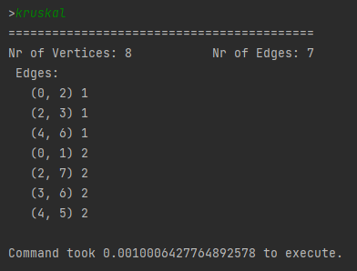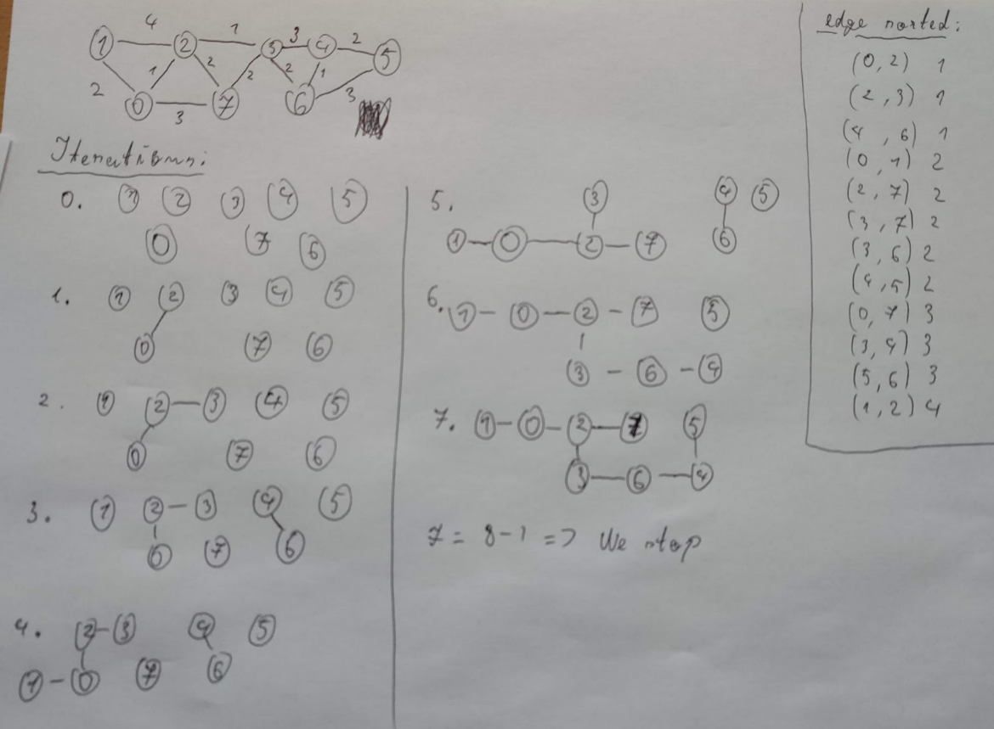**Graph with 8 vertices with 12 edges:**

**All the minimum spanning trees for a graph with 6 vertices with 9 edges (nice):**

